IACIP Webinar (December 12, 2021)

On Three Common Challenges of Global Geotechnical Profession

Yue, Zhongqi Quentin
Professor, Department of Civil Engineering, The University of Hong Kong

Abstract: In his Keynote Address at GEO Eng 2000, Professor N. R. Morgenstern pointed out and discussed that the global geotechnical profession had three common challenging issues. They were inadequate performance, inadequate compensation and inadequate recognition. This webinar talk will examine the three challenges and propose their two technical causes. The No. 1 technical cause is the inadequately expanded application of the current theories of soil mechanics. These theories were developed under and for the state of soil in completely compressive and shear stress condition. However, they have been incorrectly applied and inadequately broadened to the general stress state of soils including tensile stress components. The No. 2 technical cause is the lack of consideration of ground gas actions because of the incomplete understanding of the Earth in geology and Earth sciences. Consequently, failures in geotechnical works are not uncommon. Geo-engineers have to put their time and effort in preventing geotechnical failures in life time. Fees for geotechnical engineering can be low and inadequate. These suggested two technical causes can provide effective solutions to the three challenges that were/are faced by the global geotechnical profession.
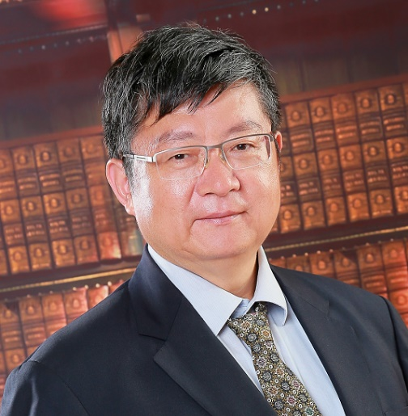
Bio: Professor Yue obtained BSc degree (1983) and MSc degree (1986) from Peking University, PhD degree (1992) from Carleton University, and PDF experience at National Research Council of Canada. He chartered as a professional engineer both in Ontario (1995) and in Hong Kong (1998). He has a total of 9 years industrial experience in Beijing, Ottawa and Hong Kong. He joined HKU in 1999. His teaching and research interests include 1) Geotechnical engineering for urban development and land reclamation and 2) Methane-based theory of earthquakes and volcanoes and the Earth. Professor Yue has published up to 500 papers and books and delivered more than 600 lectures at conferences and institutions. He has received some prestigious awards from Chinese Society for Rock Mechanics and Engineering, Mao Yi-sheng Science and Technology Education Foundation, National Natural Science Foundation of China, Chinese Alliance for Simulation-Based Engineering and Science, International Association for Computer Methods and Advances in Geomechanics, Peking University, as well as University of Hong Kong.

Date and Time:
9:30 am - 10:30 am, December 12nd (Sunday), 2021 (Beijing Time in China)
8:30 pm - 09:30 pm, December 11st (Saturday), 2021 (Eastern Time at New York)

Meeting Link:
Click the link to join the meeting: https://voovmeeting.com/s/AbykqYCEoTxE
Tencent (VooV) Meeting ID: 679 050 787
Dial in: +1 4153389272 (United States) or +1 3868680985 (United States)
Find your local number
https://voovmeeting.com/mobile/redirect?page=pstn&region=df&lang=en

论全球岩土工程领域的三项共同挑战性问题

岳中琦

香港大学土木工程系

摘要：Morgenstern教授，2000年在ISSMGE、ISRM和IAEG共同召开的“世纪岩土工程会议”上，提出和论证了全球岩土行业存在三大共同挑战性问题：表现不合格、不合理报酬和不合情地位。相应地，它们导致了相关专业人员的价值被低评、回报被低算和才华被低用。他认为，根源在于全球岩土行业缺少一个统一的学会来领导和竞争。本报告将给出和论证两类科技根源。第一，经典土力学理论是完全压剪土力学理论，但是，却被扩大应用到了存在拉张应力分量状态工况的工程中。第二，地球科技人员普遍缺乏对地下气体对岩土体破坏作用的认知和防治。扩大使用和认知缺乏科技根源导致了这三大共同挑战性问题。

个人简介：岳中琦教授在1983年获得北京大学地震地质学士，1986年获得北京大学地球动力学硕士，1992年获Carleton大学全岩土工程博士，和1993年加拿大国家研究院建筑研究所博士后。分别在1995年和1998年考取了加拿大安大略工程师（岩土）资格和香港工程师学会岩土工程师资格。他曾在综合勘察研究院（北京）、加拿大国家研究院建筑研究所（渥太华）和合乐顾问工程师有限公司（香港）从事了9年的岩土和道路工程实践。1999年以来，他一直香港大学土木工程系从事教学、科研和实践工作。他的教学、研究和实践领域包括（1）城市建设和土地开发岩土工程新方法和（2）基于甲烷气体的地震、火山和地球科学理论。他发表了将近500篇论文和专著和应邀在会议和单位做了600余次学术报告。他分别从北京大学、加拿大联邦政府自然科学和工程基金、茅以升科技教育基金会、国家自然科学基金委员会、国际岩土力学计算方法与进展学会、中国岩石力学与工程学会、中国数字仿真联盟、和香港大学获得了重要奖励。

