IACIP Webinar (December 17th [9:30 PM China]/[8:30 AM EST USA], 2022)
Long-term performance and multi-scale characterization and simulation
of cement treated base material
Qiao Dong, Professor, School of Transportation, Southeast University
Abstract: Most of the pavements in China use the semi-rigid base, such as the cement treated base (CTB). With the increase of pavement service time, the durability of the CTB has become the key for the long-term preservation of pavements. Experience from Europe shows that CTB could be used for long-life pavement structure as long as the tensile stress or strain at the bottom of the layer is controlled within a specific range. This presentation reports a study on the performance of in situ CTB layer and cores, the micro scale mechanical property and composition, the meso scale fatigue simulation of CTB using discrete element model (DEM) method, and the applications of DEM in other meso scale simulations of pavement materials.
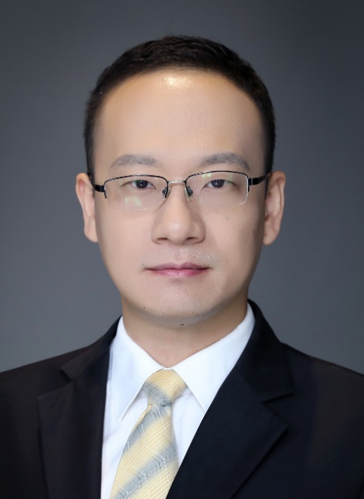
Qiao Dong is a professor in the School of Transportation at Southeast University, China. His research interests include pavement maintenance based on data mining and artificial intelligence, pavement non-destructive evaluation and real time sensing, pavement materials multi-scale characterization and simulation, and sustainable and functional pavement materials. He is the primary investigator of research projects funded by the national natural science foundation, the Jiangsu natural science foundation, and the Jiangsu Department of Transportation. He is currently an active member of the Bituminous Materials Committee (BMC) of ASCE, the Pavement Maintenance Committee (AHD20) of TRB and several committees of the WTC. He serves as the young editor for the China Journal of Highway and Transport, Journal of Infrastructure Preservation and Resilience, and Journal of Road Engineering and has been providing review works for more than 50 international academic journals.

Date and Time:
9:30 pm-10:30 pm, December 17th (Saturday), 2022 (Beijing Time in China)
8:30 am-09:30 am, December 17th (Saturday), 2022 (Eastern Time at New York)
Meeting Link:
Click the link to join the meeting: https://voovmeeting.com/dm/tQyin2hPs6Tk
Tencent (VooV) Meeting ID: 770-0762-7504
Dial in +1 4153389272 (United States) (E-mail of the presenter: qiaodong@seu.edu.cn)

