IACIP Webinar (August 22, 2021)

Feasibility Study on the Intelligent Monitoring of Pavement Performance

Jinxi Zhang
Professor, College of Metropolitan Transportation, Beijing University of Technology

Abstract: Along with the continuous construction of transportation infrastructure and increase of road networks, the rapid detection, evaluation, and the real-time monitoring of pavement performance become more and more important for upgrading the information and intelligence level of pavement management. In this talk, the feasibility study on intelligent monitoring method of pavement performance using the emerging technologies is presented. A smartphone App was developed based on the Android system, which is used to collect the speed, three-way vibration acceleration, time, GPS position and other information data of driving vehicles, and the collected data can be uploaded to the Website by using 4G information transmission technology. In the meantime, a Website platform, called Pavement Condition MAP (Monitoring and Analysis Platform, Website: http://www.pavementmap.com), was developed to accept the data uploaded by App. The platform can complete the pre-process, de-noise, model calculation, and then output the calculated results of pavement performance index, which can also be displayed in the road network map using different colors. Through a number of driving tests, the calculation models of IRI (International Roughness Index) and RD (Rut Depth) were established. This technology can not only provide rapid detection and evaluation of pavement performance, but also realize the real-time intelligent monitoring of pavement performance by integration with the Internet, navigation, big data, and other modern emerging technologies.

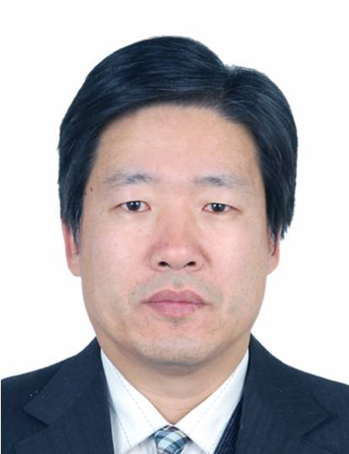
Bio: Prof. Jinxi Zhang serves as Professor and Doctoral Supervisor in the Faculty of Architecture, Civil and Transportation Engineering of Beijing University of Technology. He received his Bachelor's degree from Hebei University of Technology in 1985, a Master's degree from Beijing Research Institute of Municipal Engineering in 1988, and a Doctoral degree from Iwate University of Japan in 2000. From 1988 to 1996, he worked in the Beijing Research Institute of Municipal Engineering, Beijing Municipal Engineering Bureau. From 2000 to 2003, he worked as a Lecturer and Associate Professor in the Department of Civil and Environmental Engineering at the Faculty of Engineering of Iwate University of Japan. Since 2003, he has worked in College of Civil and Architectural Engineering, College of Metropolitan Transportation and Faculty of Architecture, Civil and Transportation Engineering of Beijing University of Technology. He currently serves as the Committee Member of Road Transport and Engineering Teaching Guiding Committee of the Ministry of Education of the People’s Republic of China, the Committee Member of Road Engineering Branch Committee of the Chinese Highway Society, Executive Member of the committee of Beijing Highway Society, etc. His research interest includes new materials for road engineering, recycling of waste materials in road engineering, durability of road structure, and detection and evaluation methods of pavement performance. Prof. Zhang has presided over more than 20 scientific research projects, including 4 general projects of the National Natural Science Foundation of China.

Date and Time:
9:30 am - 10:30 am, August 22nd (Sunday), 2021 (Beijing Time in China)
9:30 pm - 10:30 pm, August 21st (Saturday), 2021 (Eastern Time at New York)

Meeting Link:
Click the link to join the meeting: https://voovmeeting.com/s/XmwPtMHJyJL3
Tencent (VooV) Meeting ID: 277 066 314
Dial in: +1 4153389272 (United States) or +1 3868680985 (United States)
Find your local number
https://voovmeeting.com/mobile/redirect?page=pstn&region=df&lang=en

